**OUTPUT FOR ARTICLE MANAGEMENT API**

Output :

1. After Running the Server

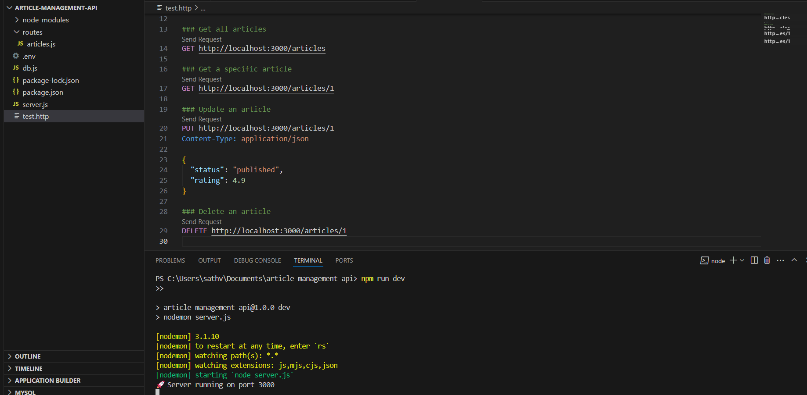

1. Creating an Article (POST /articles)

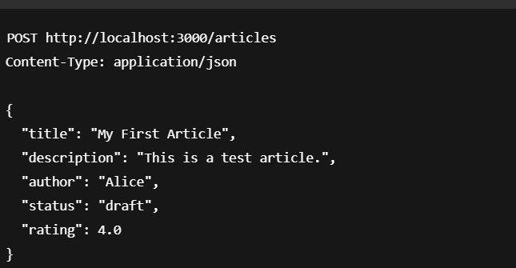

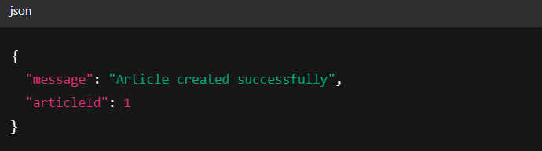

1. Getting All Articles (GET /articles)



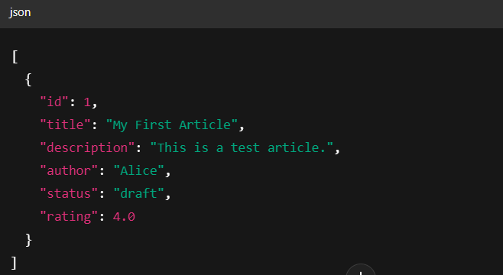

1. Updating Article (PUT /articles/1)

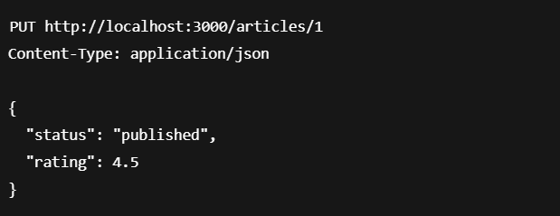

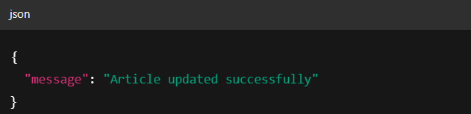

1. Deleting Article (DELETE /articles/1)



